1, 2, 5, 9, 13, 30, 49, 50, 51, 65, 71

             —>

1. f(a) = (1,2)

  —>

    f(b) = (1,3)

  —>

    f(c) = (2,3)

  —>

    f(d) = (2,2)

2.

a. Yes

b. No

c. Yes

d. (3 —>  4 —> 5 —> 6) & (3 —> 5 —>6)

e. 3 —> 4 —> 5 —> 3

f. a5

g. a1

5.

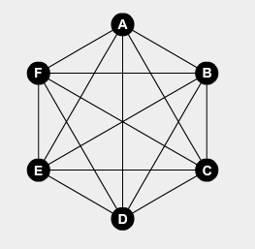

9.

a. The two graphs are unassociated. The two departments don’t communicated or know anything about each other.

b. Carl and Fletcher don’t know each other and Yuri is acquainted with only 2 people

13. Graph A and C are isomorphic to each other because they both contain the same amount of connected nodes and vertices. If you take graph A you can transform it to make the shape of graph C but not graph B. So graph B is not isomorphic to the other graphs.

30. It gets split into 7 regions

49. Each node should have a loop

50. The graph is a bunch of nodes that do not connect to one another.

51. The matrix will have ones in every position except in a downward diagonal demonstrating that aren’t any loops

65.

71. The adjacency matrix is will have all the ones and zeros switched, excluding the zeros that go down the middle.